Meeting Report on
Consultation on User Guide tools for Environment Mainstreaming

Venue: Qutab Hotel, New Delhi

29th November 2007

Development Alternatives
111/9-Z, Kishangarh, Vasant Kunj,
New Delhi - 110070, INDIA
Tel: +91-11-2613 4103, 2689 0380, Fax: +91-11-2613 0817
E-mail: akumar3@devalt.org Visit us: www.devalt.org

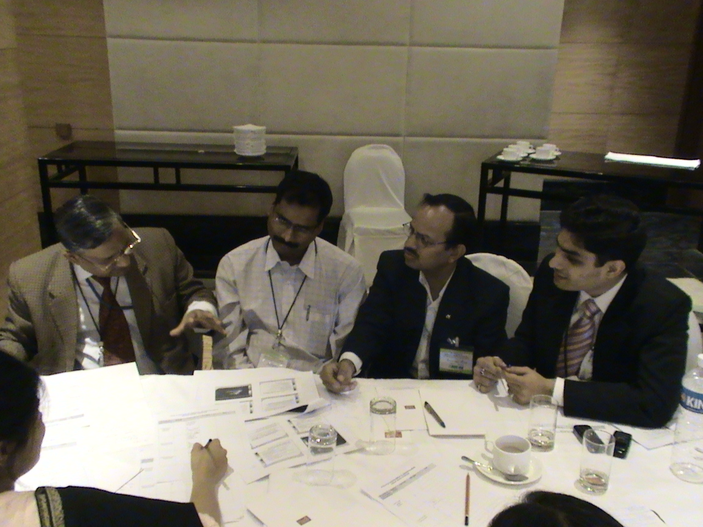
International Institute of Environment and Development (IIED) London has launched an initiative to produce a User Guide to tools and tactics for integrating environment into development decesion making (environment mainstreaming). A one day workshop was held as the Consultation Meeting on the User Guide tools for Environment Mainstreaming. The meeting was organised by Development Alternatives (DA) in collaboraton with IIED. It was held at the Qutab Hotel, New Delhi. The meeting was attended by representatives from the Government sector, financial institutions, civil society, academia as well as representatives from Development Alternatives. Dr.Barry Dalal-Clayton (IIED), Mr.George C.Varughese (DA), Dr S.P Sharma (MoEF, Govt. Of India) were the distinguished Panel members. Dr.(Mrs) K.Vijayalakshmi, Mr.Anand Kumar and Ms.Ridhima Sud represented the project team from DA.
The project was initiated by IIED,with an international stakeholders panel.The aim of the project is to prepare a User Perspective Guide to various tools and methods to foster the stakeholders efforts towards integration of environmental issues in policy making. The purpose of the workshop was to provide a platform to bring together participants from all key sectors and inititate a dialogue to discuss and analyse the recommended methodologies for mainstreaming and arrive at a consensus on the best available tools which ae being used in decesion making process for environmental mainstreaming in India.
Welcome address: Mr. George C Varughese, Development Alternatives
George C.Varughese welcomed the participants to the workshop.He gave backdrop of the project and encouraged the participants to critically review and analyse the findings of the survey so as to strengthen the final report . Mr.George C.Varughese spoke about the collaborative efforts of the various international organisations and the international panel,laying emphasis on the importance of the initiative in the global and local context.
Dr. S.P. Sharma, Advisor, Ministry of Environment and Forests, GoI
In his address, Dr. Sharma stated the emerging environmental challenges in India. His major concern was to highlight the inter-linkages between poverty, inequality and environment .On the issue of environment mainstreaming, he laid emphasis on the need to strike a balance between develpment priorites and environment promotion. He said there needs to be a delicate balance where in, both the development activitites and environment resources are accounted for as both are important for the society.
Dr D.B.Dalal-Clayton, International Institute for Environment and Development
Dr.Barry extended a warm welcome to the participants.He gave a short insight on the project,informing the participants on the inception, where all its is being undertaken, the people involved and the organisations that have teamed up for this project.
Presentation on global environmnetal issues and methods to environment mainstreaming by Dr. Barry
Dr. Barry’s presentation highlighted on the key challenging issues pertaining to environment with stress on climate change impacts globally. During the course of the presentation, he emphasized the need to have an open and broader perspective to view the tools as methods or approches, a means for incorporating environmental concerns in decision making. To make it simpler for the audience, his presentation comprised of what environmnetal mainstreaming meant, how it can be achieved and who could be responsible for steering the process.
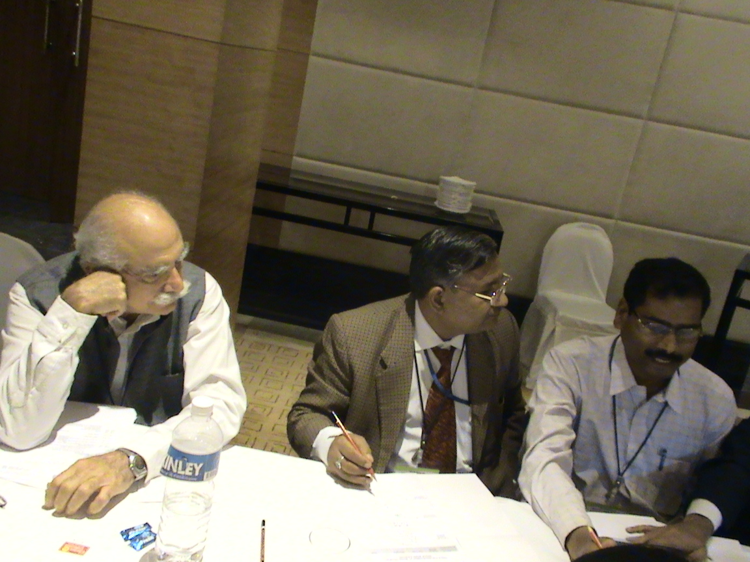
The presentation was folllowed by a series of queries and clarifications from the participants regarding the initiative. These were responded to by the panel.
Presentation on the outline and Process of Country Survey for User Guide to Tools for Environment mainstreaming by Mr. Anand Kumar
Mr.Anand Kumar presented on the “Outline and process of the country Survey”. During his presentation, he gave an overview of the process which was followed during the country survey and also detailed out the outline of the draft report.
Presentation on findings of Country Survey for User Guide to Tools for Environment mainstreaming by Ms. Ridihima Sud
The presentation by Ms.Ridhima Sud, highlighted the various tools and methods for mainstreaming the environment, the “user perspective” on the same, laying emphaisis on how it can be ahcieved and the challenges that arise in their usage.The presentation was a crisp insight of the draft report, based on findings from the user groups.
A number of questions and recommendations followed the presentation, which were duly acknowledged by the team for future reference during compilation of the final report.
Group exercise
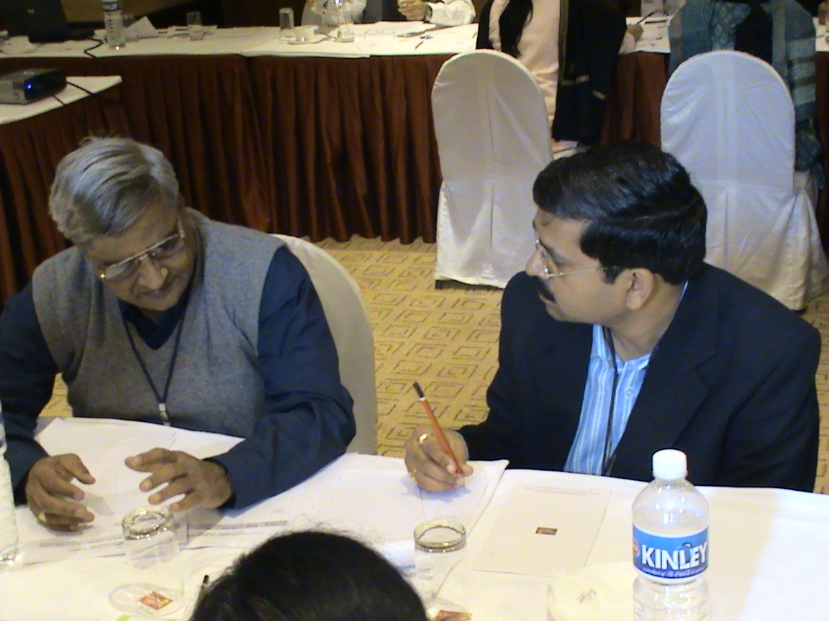
The group exercise was the core part of the workshop as it deliberates on the actual tools and methodologies being used in India for decesion making process into environmental mainstreaming. Participants were divided into a random set of two groups.The objective of the group-work was to share views on the various tools used in decesion making for environmental mainstreaming and at the same time assess the strenghts of the each tools. For this purpose, they were provided with a well structured format to arrive at the top tools to perform the key tasks for mainstreaming environment. The braining storming session continued for over an hour.

Group Presentation
On the basis of the groups findings,Dr.Sharma and Mr.Emani,reperesenting their respective groups,made presentations on the subject, the copy of which has been attached.
Concluding Session
In the concluding sesion Dr.Barry,expressed his gratitude to the participants and stressed on the need for joint effort from all the participants and other institutions/organizations, through their network to find concerete set of tools in addressing environmnet intergration in policy making rather than accepting the generic methods in use.
For the closing remarks,Mr.George C.Varughese,apprecited the participants efforts on being a part of the workshop and stressed the need to build a network amongst the stakeholders.
The workshop concluded with a vote of thanks
TOOLS FOR ENVIRONMENTAL MAINSTREAMING
GROUP WORK EXERCISE (Group1)

Key tasks for Environmental Mainstreaming | Rank by priority | Top Tools | Strengths | Gaps
Training and Capacity Building |  | 1. Mandatory orientation programmes | All stakeholders are covered | Lake of awareness
Training and Capacity Building |  | 1. Mandatory orientation programmes |  | Can become a “routine” exercise
Training and Capacity Building |  | 2. Environment Integration in all subjects across all sectors & levels | Environment is integrated in all sectors | Lake of coordination
Training and Capacity Building |  |  |  | No holistic vision
Environmental Assessments |  | 1. SBCA,  IEA | Holistic approach | Complex process
Environmental Assessments |  | 1. SBCA,  IEA | Participatory approach | Time consuming
Environmental Assessments |  | 1. SBCA,  IEA | Addresses Local needs
Environmental Assessments |  | 2. Natural Resource Accounting | Realistic assessment  (not misguided GDP growth) | Methodological constraint
Information and Awareness |  | 1.Strengthening the existing information systems e.g. ENVIS | Institutional Network | Limited reach, access
Information and Awareness |  | 1.Strengthening the existing information systems e.g. ENVIS | Scientifically robust
Information and Awareness |  | 2. Publicity  Media | Mass coverage | Balanced information
Information and Awareness |  | 2. Publicity  Media | Key requirement for mainstreaming | Regional biases

Monitoring and Enforcements |  | 1. Indicators | Uniformity, balanced and focused approach | Conflicting indicators
Monitoring and Enforcements |  | 1. Indicators | All – encompassing | Quantitative parameters not available
Monitoring and Enforcements |  | 2. Innovatory Regulation Approach | Local concerns taken care off | Untested
Monitoring and Enforcements |  | 2. Innovatory Regulation Approach | Flexibility | Enforceability
Planning and Management |  | 1. Prioritizing sectors for mainstreaming |  | Many sectors overlooked
Planning and Management |  | 1. Prioritizing sectors for mainstreaming | Focused
Planning and Management |  | 2. Effective fiscal instruments | Environment Governance | Financial allocation (constraints and mis-directions)
Planning and Management |  | 2. Effective fiscal instruments | Linked to investments
Any Other |  | 1.
Any Other |  | 2.

TOOLS FOR ENVIRONMENTAL MAINSTREAMING
GROUP WORK EXERCISE (Group 2)

Key tasks for Environmental Mainstreaming | Rank by priority | Top Tools | Strengths | Gaps
Training and Capacity Building |  | 1. Seminars,  community visits |  | Local level training
Training and Capacity Building |  | 2. Focused discussions. Knowledge sharing
Environmental Assessments | Life cycle assessments  Community based EIA  Strategic Environment Assessment | 1. EIA, Remote sensing & GIS  2. Community based monitoring |  | EIA for cluster of SMES
Environmental Assessments |  | 1. EIA, Remote sensing & GIS  2. Community based monitoring |  | Tools for ecosystems analysis
Environmental Assessments |  | 2. Zoning Atlas  GHG emissions calculations
Information and Awareness |  | 1. RTI  Visual tools  Street short plays, cartoons  Citizens & Govt. partnerships |  | Tools for satellite data for villages level application
Information and Awareness |  |  |  | Awareness on spatial tools
Information and Awareness |  | 2. Bhagidhari Scheme  Eco clubs |  | Tools for precautionary measures

Monitoring and Enforcements | Local area environment monitoring committee  RWA schemes  EMP – Enforcement SPCBs  Participatory monitoring  Indicators | 1. Green rating |  | Self imposed
Monitoring and Enforcements |  | 1. Green rating |  | Periodic environment monitoring
Monitoring and Enforcements |  | 2.
Planning and Management | ISO 14001  Resource Maps  Land Use/ Local Cover  PRA technique  District Planning Report | 1. cost benefits analysis |  | Tools for precautionary measures
Planning and Management |  | 2.
Any Other | Resource Efficiency  Mapping tools | 1.
Any Other | Resource Efficiency  Mapping tools | 2.

List of Participants

Sl. No. | Name | Organisation
1 | George C Varughese | Development Alternatives
2 | Dr. S. P. Sharma | MoEF, GOI
3 | D. B. Dalal | IIED
4 | Rajneesh Sareen | WWF-India
5 | Col. V. Katju | Development Alternatives
6 | S. Parthasarathy, IAS (Retd.) | Consultant
7 | Dr. S. K. Barik | N.E. Hill University
8 | Avenash Datta | Help Age India
9 | Ashok Emani | IDFC Ltd.
10 | Pankaj K. Verma | IDFC Ltd.
11 | Tania Plahay | British High Commission
12 | Prakash Rao | WWF-India
13 | Suprava Patnaik | IIFM-Bhopal
14 | Aditya Singh | Dept. of Environment, GNCTD
15 | K. Vijayalakshmi | Development Alternatives
16 | Anand Kumar | Development Alternatives
17 | Ridhima Sud | Development Alternatives
18 | Udaypal Singh Sandhu (Rapporteur) | Development Alternatives

